Serial Number: R44SD5WAKWIH

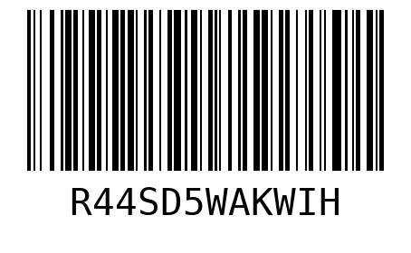

Serial Number: WX6OBLLN2GIP

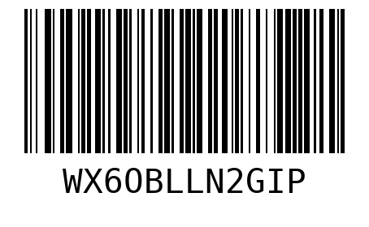

Serial Number: HVZSLWFKOJBA

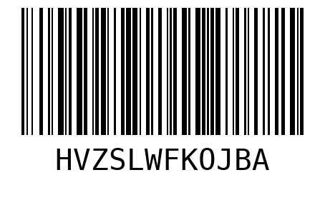

Serial Number: 8LSEKUIEFUIZ



Serial Number: ZVRRW4XDNPDZ

